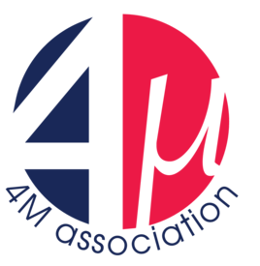
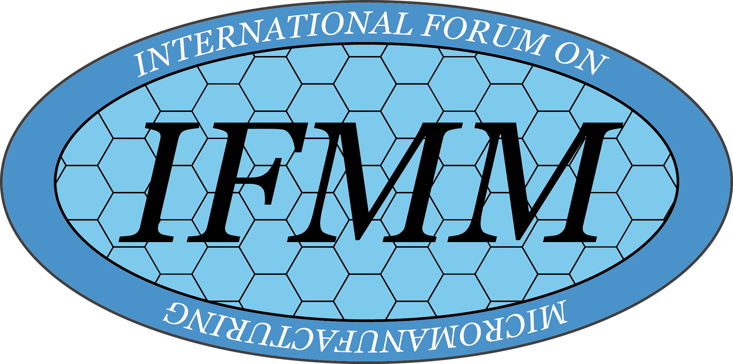
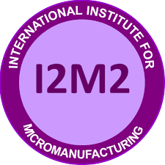

WCMNM 2022
5th World Congress on Micro and Nano Manufacturing
Jointly organised by the 4M Association, the International Institution for Micro Manufacturing (I2M2) and the International Forum on Micro Manufacturing (IFMM)

Congress Chair: Sylvie Castagne, KU Leuven, Belgium

Congress Co-Chairs: Stefan Dimov, University of Birmingham, UK
Lawrence Kulinsky, University of California, Irvine, USA
Kuniaki Dohda, Northwestern University, USA
Dominiek Reynaerts, KU Leuven, Belgium

Scientific Committee Chairs: Pierre Vella, University of Malta (4M)
Ming-Chyuan Lu, National Chung Hsing University, Taiwan (I2M2)
Tohru Sasaki, University of Toyama, Japan (IFMM)

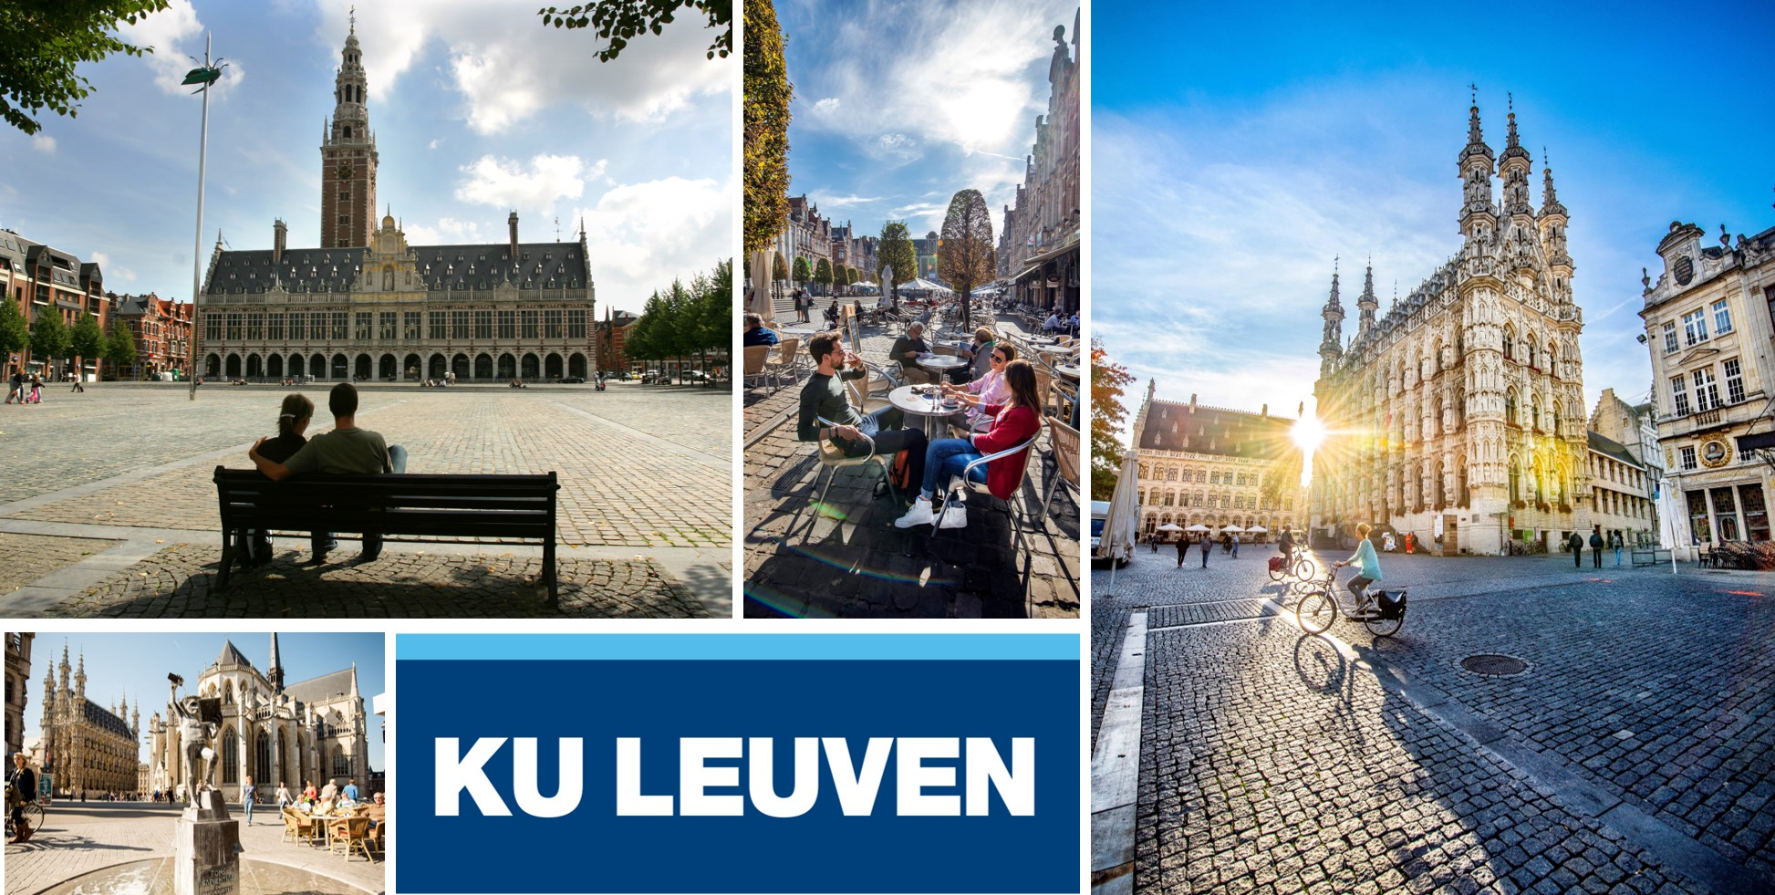

19th-22nd September 2022
Leuven, Belgium

Co-Organised by KU Leuven, 4M Association, IFMM, I2M2


https://www.4m-association.org/conference/WCMNM2022/wcmnm2022.html
Themes
Papers are sought to address theoretical and applied research issues related to manufacture, assembly and metrology for components and systems with nano/micro/meso-scale features and dimensions.

Topics to be covered, but not limited to:

- Micro fabrication technologies, process chains and process characterization
- Miniaturization of machines and equipment; positioning, motion generation, sensors systems, and control
- Novel product designs, micro-assembly technologies and micro-handling
- Surface engineering and interface nanotechnology
- Process modelling and simulation
- Processing and characterization of smart materials, energy materials, metamaterials and nanomaterials
- Micro and nano additive, subtractive, joining, and hybrid manufacturing technologies
- Micro and desktop factory concepts, systems, components and modules
- On-line monitoring and inspection systems, and smart manufacturing
- Standardization in micro manufacturing and micro factories
- Applications of micro and nano technologies
- Emerging micro manufacturing methods and equipment, including those that bridge the nano- and macro- worlds
- Biomanufacturing and biomedical devices

These themes represent the intended content of the WCMNM 2022 thematic sessions, to which the authors are invited to submit papers.
Invited Speakers:
- Professor Jian Cao, Northwestern University (USA)
Research Interests: Innovative manufacturing processes and systems, particularly in the areas of deformation-based processes and laser processes; Characterization of the effects of material structure on forming behaviour of metals and woven composites
- Professor Takashi Matsumura, Tokyo Denki University (Japan), Department of Mechanical Engineering
Research Interests: Machining process modeling, Optimization Micro/nano machining (cutting, grinding, polishing, water jet, FIB); Tribology, Surface engineering: Computer-aided Manufacturing; Manufacturing Process/Systems

Submission of Full Papers and Peer Review
We invite you to submit 4-page papers using the template provided on the conference website.
Link for submission: https://conf.papercept.net/conferences/scripts/start.pl

All papers will be peer reviewed by members of the Scientific Committee under the leadership of the Scientific Committee Chairs. Submitted papers may be selected for oral or poster presentation. All oral and poster presentations will be included in the Conference Proceedings.
Important Dates
- Paper submission site opens: 15th of January 2022
- Submission deadline for full papers: 30th of April 2022
- Feedback from the peer review to authors: 4th of June 2022
- Submission deadline of revised final paper: 18th of June 2022
- Congress dates: 19th to 22nd of September 2022

Scientific Committee

Tatsuhiko Aizawa
Massimiliano Annoni
Kiwamu Ashida
Vito Basile
Samuel Bigot
Giuliano Bissacco
Stefania Bruschi
Evgueni Bordatchev
Jian Cao
Sylvie Castagne
Amal Charles
Pin-Chuan Chen
Kai Cheng
Chunhui Chung
Stefan Dimov
Gianluca D'Urso
Kornel Ehmann
Ahmed Elkaseer
Irene Fassi
Eleonora Ferraris
Ming-Wang Fu
Tatsuya Funazuka
Yanquan Geng
Christian Griffiths
Ping Guo
Hans Nørgaard Hansen
Tong Hao
Wen-Jeng Hsue
Suhas Joshi
Martin Byung-Guk Jun
Shiv Kapoor
Yannis Korkolis
Lawrence Kulinsky
Senthil Kumar
Antony Lee
Kuan-Ming Li
Yong Li
Yunn-Shiuan Liao
Chorng- Tyan Lin
Ming-Chyuan Lu
Giovanni Lucchetta
Numpon Mahayotsanun
Deepak Marla
Valeria Marrocco
Yasuo Marumo
Davide Masato
Paul Mativenga
Takashi Matsumura
J. Rhett Mayor
Yonggan Meng
Hussein Mohamed
Balasubramanian Nagarajan
Wataru Natsu
Gracious Ngaile
José Ocaña
Burak Ozdoganlar
Simon Park
Petko Petkov
Frank Pfefferkorn
Wilhelm Pfleging
Volker Piotter
Raphaël Pugin
Yi Qin
Mariangela Quarto
Iban Quintana
Kamlakar Rajurkar
Lara Rebaioli
Andrew Rees
Claudia Pagano
Pavel Penchev
Izidor Sabotin
Tanveer Saleh
Tohru Sasaki
Krishna Kumar Saxena
Albert Shih
Ramesh Singh
Xu Song
Marco Sorgato
Sathyan Subbiah
Rossella Surace
Guido Tosello
Yao-Yang Tsai
Joško Valentinčič
Pierre Vella
Thomas Velten
J.-J. Junz Wang
Shih-Ming Wang
Zongwei Xu
Jiwang Yan
Yongda Yan Harbin
André Zimmermann
Wansheng Zhao

Awards
- The Elena Ulieru Innovation Award for the best paper presentation by a young female scientist sponsored by SITEX 45
- Best Student Presentations Award sponsored by Micromachines
- Best Paper Award sponsored by Micromachines

Venue
Leuven is the largest city of the province of Flemish Brabant in the Flemish Region of Belgium. It is located about 25 kilometres (16 miles) east of Brussels. With its historic centre Leuven is one of the most beautiful and atmospheric towns in Belgium. The congress will be held at Onderwijs en Navorsing (O&N) in Leuven.
Proceedings
All final papers will be included in the WCMNM 2022 Proceedings to be published by Research Publishing Services, in both hardcopies and electronic format (copyrights remain with the authors).
In addition, selected papers will be invited for publication in the Special Issue of Micromachines.

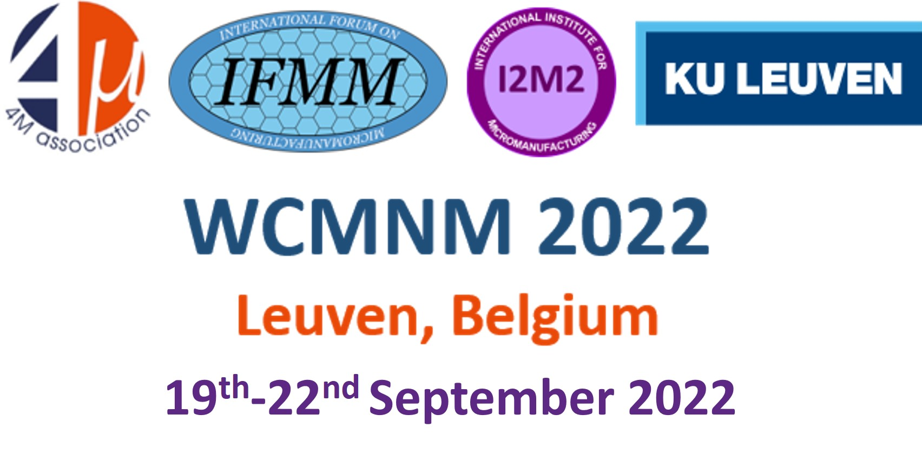
4M Association Officer
Adriana Svetozarova
University of Birmingham, Edgbaston, Birmingham B15 2TT, UK
E-mail: a.svetozarova@bham.ac.uk

